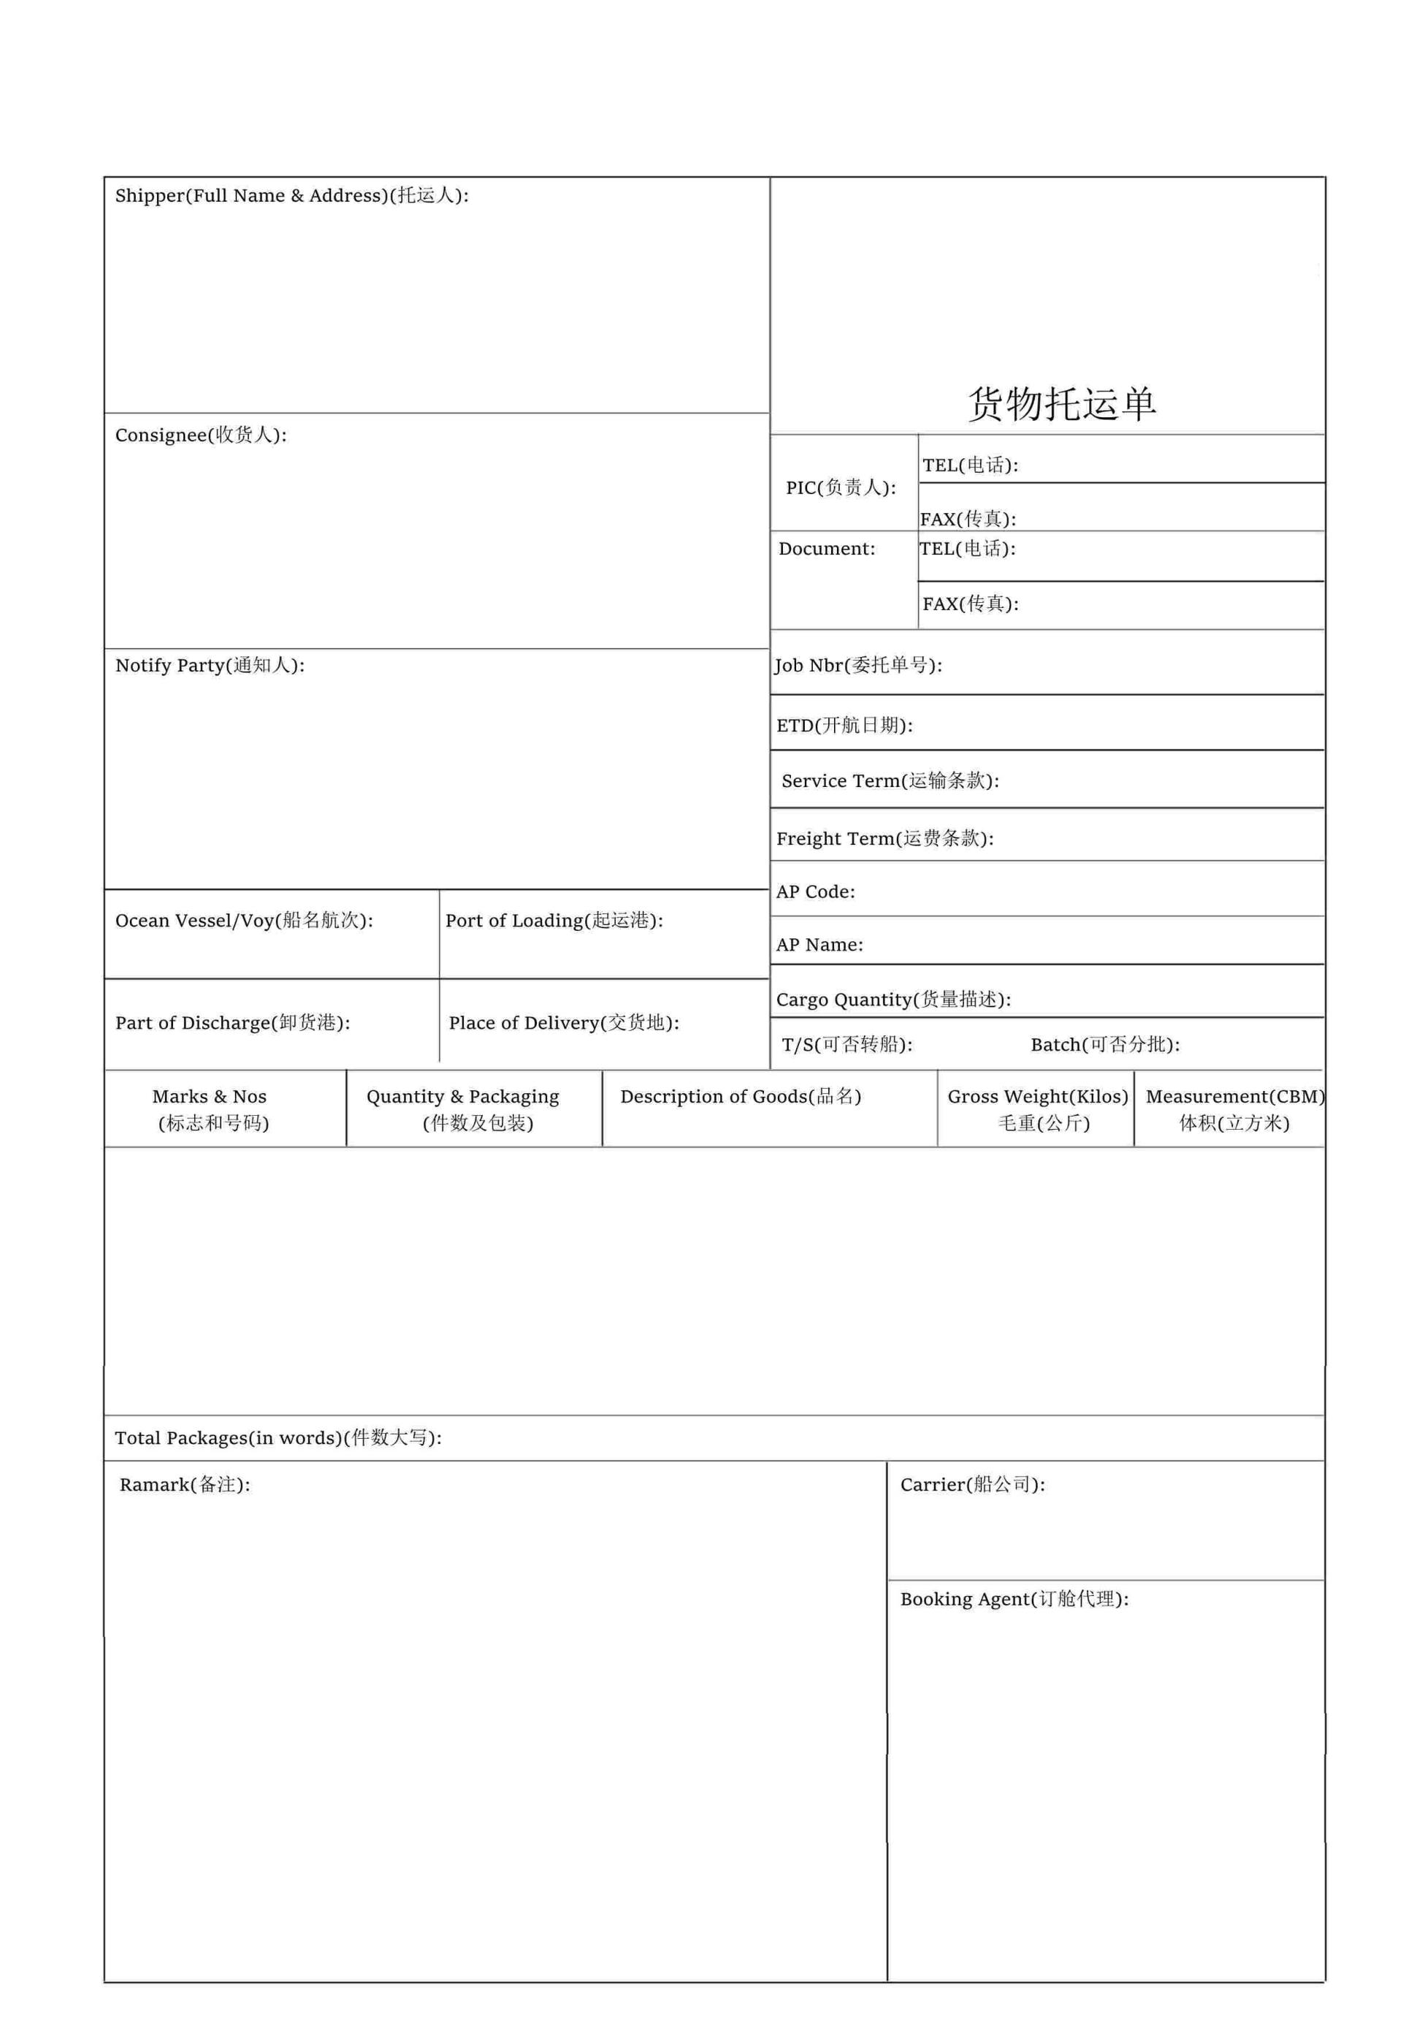

**上海岸一桥国际物流有限公司**

JYDSEM21090360

李静

上海岸一桥国际物流有限公司

1058

SHANGHAI JIYIDA INTERNATIONAL LOGISTICS CO.,LTD\N RM1304-1306,BULIDING A,HESHENG FORTUNE PLAZA,\N NO.839 DALIAN RD, HONGKOU DIS,SHANGHAI,CHINA\N TEL:021-63930701\N FAX:021-63930650

VELTA INTERNATIONAL LTD

COMPASS HOUSE EASTWAYS WITHAM, ESSEX, CM8 3YQ

TEL: +44 (0) 1376 505160

SAME AS CONSIGNEE

SHANGHAI

FELIXSTOWE

FELIXSTOWE

CARTONS

10-25-FELIXSTOWE 1*40HQ

加拼20个关单号

FM:岸一桥

TOTAL:ONE THOUSAND ONE THOUSAND FIFTY EIGHT(1058)CARTONS ONLY.

PP

40HQX1

40HQX1

021-63930701

14231.75KGS

66.23CBM

CY-CY

343